Ideation Phase Empathize & Discover

|  |  |
| --- | --- |
| Date | 01 November 2022 |
| Team ID | PNT2022TMID11798 |
| Project Name | Real time water quality monitoring and control system |
| Maximum Marks | 4 Marks |

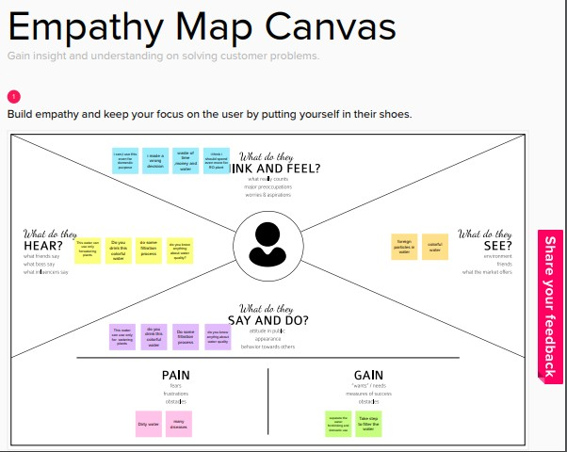

Reference Link:[https://app.mural.co/t/jansonsinstituteoftechnology4907/m/jansonsinstituteoftechnol](https://app.mural.co/t/jansonsinstituteoftechnology4907/m/jansonsinstituteoftechnology4907/1663995478539/c25f801a8830f64aca427b8cae022e6efc69596e?sender=u8ae0c1599014533bb2e95539) [ogy4907/1663995478539/c25f801a8830f64aca427b8cae022e6efc69596e?sender=u8ae0c1](https://app.mural.co/t/jansonsinstituteoftechnology4907/m/jansonsinstituteoftechnology4907/1663995478539/c25f801a8830f64aca427b8cae022e6efc69596e?sender=u8ae0c1599014533bb2e95539) [599014533bb2e95539](https://app.mural.co/t/jansonsinstituteoftechnology4907/m/jansonsinstituteoftechnology4907/1663995478539/c25f801a8830f64aca427b8cae022e6efc69596e?sender=u8ae0c1599014533bb2e95539)